Installation Instructions for COS

Requirements:
Apache Web Server (http://httpd.apache.org)
PHP module for Apache (http://www.php.net)
MySQL database (http://www.mysql.org) (you might also want to get a good administration tool for MySQL such as MySQL Control Center)

Installation:
- Copy openSDRM.zip to the Apache web server root (<SERVER_ROOT>) and extract it;
- Create a directory called ‘WServices’;
<SERVER_ROOT>/WServices
- Copy ‘config.inc.php’ from the <SERVER_ROOT>/WServices/opensdrmWS to <SERVER_ROOT>. Configure the appropriate values in the file. Beware if you already have one there, because you may want to skip this step;
- Copy ‘configCOS.inc.php’ from the <SERVER_ROOT>/WServices/opensdrmWS/COS to <SERVER_ROOT>. Configure the appropriate values in the file. Beware if you already have one there, because you may want to skip this step;
- Create the appropriate MySQL database, called ‘cosWS’ using the instruction id the SQL file (‘cosWS.sql’) located in <SERVER_ROOT>/WServices/opensdrmWS/COS/database
- Start web-browser and point it to the following URL:
http://<SERVER>/WServices/opensdrmWS/COS/admin/index.php
- Enter the data requested in the form. The generation of the keys may take some time (quite a long time in fact);
- The COS will automatically connect to the AUS web-service and register itself in it. This is a critical aspect of the system, the correct values of this web service registration must be configured in ‘configCOS.in.php’;
- And COS setup is done. At least the Web Services component part.

This COS admin tool will be used to modify and change several aspects of the COS.

How to have a user registered on the AUS server from COS
This is used to subscribe a new user on the generic AUS server from the COS interface. This will allow having a centralized control point over all users on the system. This part supposes that the previous parts were performed already and that the COS is already registered as an AUS component.

Supposing you have the following form on COS server:
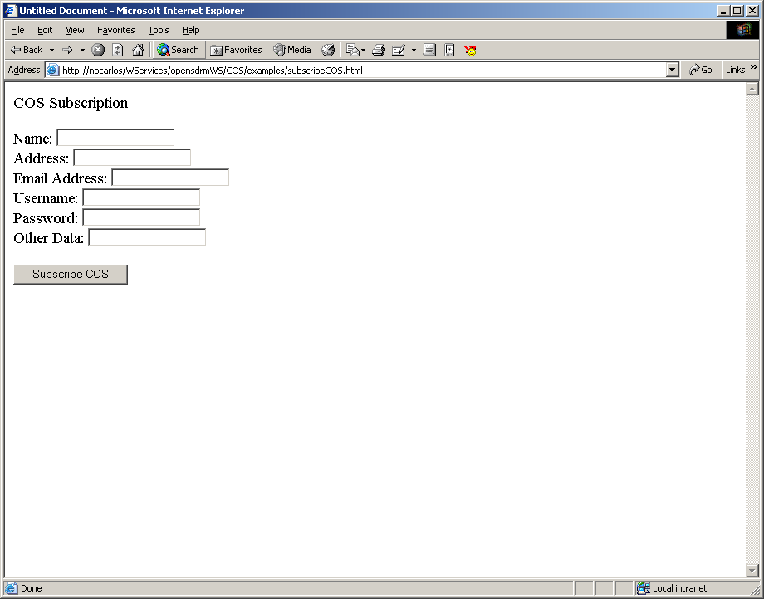

With the following HTML code:

<!DOCTYPE HTML PUBLIC "-//W3C//DTD HTML 4.01 Transitional//EN">
<html>
<head>
<title>Untitled Document</title>
<meta http-equiv="Content-Type" content="text/html; charset=iso-8859-1">
</head>

<body>
<p>COS Subscription</p>
<form action="subscribeCOS.php" method="post" name="subscribeForm" id="subscribeForm">
Name:
<input name="name" type="text" id="name">
<br>
Address:
<input type="text" name="address" id="address">
<input name="authentication_type" type="hidden" id="authentication_type" value="LOGINPASSWORD">
<br>
Email Address:
<input name="email" type="text" id="email">
<br>
Username:
<input name="username" type="text" id="username">
<br>
Password:
<input type="password" name="password">
<br>
Other Data:
<input name="other_data" type="text" id="other_data">
<br>
<br>
<input type="submit" name="Submit" value="Subscribe COS">
</form>
<p>&nbsp; </p>
</body>
</html>

Note: Currently AUS has some problems handling TEXTAREA data, so PLEASE don’t use it :) at least for now.

After inserting all the appropriate data on the form, it will call the ‘subscribeCOS.php’ script. This script is as follow:

<?
/*
OpenSDRM - Open Secure Digital Rights Management
Copyright (c) 2002 Adetti/MOSES

This library is free software; you can redistribute it and/or
modify it under the terms of the GNU Lesser General Public
License as published by the Free Software Foundation; either
version 2.1 of the License, or (at your option) any later version.

This library is distributed in the hope that it will be useful,
but WITHOUT ANY WARRANTY; without even the implied warranty of
MERCHANTABILITY or FITNESS FOR A PARTICULAR PURPOSE. See the GNU
Lesser General Public License for more details.

You should have received a copy of the GNU Lesser General Public
License along with this library; if not, write to the Free Software
Foundation, Inc., 59 Temple Place, Suite 330, Boston, MA 02111-1307 USA

* Created by: Carlos Serrao - ADETTI
*
* Description:
* ...
*
*/
/*
* Created by: Carlos Serrao - ADETTI
*
* Description:
* ...
*
*/

//AUS test client
include_once($_SERVER["DOCUMENT_ROOT"]."configCOS.inc.php");
require_once($_SERVER["DOCUMENT_ROOT"].$GLOBALS_CONFIG['INSTALLATION_DIR']."lib/nusoap-$NUSOAP_VERSION/nusoap.php");
include_once($_SERVER["DOCUMENT_ROOT"].$GLOBALS_CONFIG['INSTALLATION_DIR']."lib/common/RSASignature.class.php");
include_once($_SERVER["DOCUMENT_ROOT"].$GLOBALS_CONFIG['INSTALLATION_DIR']."lib/common/PublicKey.class.php");
include_once($_SERVER["DOCUMENT_ROOT"].$GLOBALS_CONFIG['INSTALLATION_DIR']."lib/common/PrivateKey.class.php");

include_once($_SERVER["DOCUMENT_ROOT"].$GLOBALS_CONFIG['INSTALLATION_DIR']."opensdrmWS/COS/admin/COS_Administrator.class.php");

$COS_Admin = new COS_Administrator();
$COS_Admin->getData();

$sig = new RSASignature();

$arbitrary_data = "<arbitrary_data><other_data>$other_data</other_data></arbitrary_data>";

$data_to_sign = implode("", array("USER_REGISTRATION_REQUEST", $COS_Admin->cert->certificate["subjectData"]["identification"], "RSA_MD5", $name, $address, $email_address, "LOGINPASSWORD", $username, $password, "", $arbitrary_data));
$signature = $sig->RSA_sign($data_to_sign, $COS_Admin->privkey);

echo "<br>$data_to_sign</br>";

//function requestUserSubscription($message_type, $identification, $signature_algorithm_identifier, $name, $address, $email_address, $authentication_type, $username, $password, $public_key, $arbitrary_data, $signature)

//$data_to_verify = implode("", array($message_type, $identification, $signature_algorithm_identifier, $name, $address, $email_address, $authentication_type, $username, $password, $public_key, $arbitrary_data));

$parameters = array(
"message_type" => "USER_REGISTRATION_REQUEST",
"identification" => $COS_Admin->cert->certificate["subjectData"]["identification"],
"signature_algorithm_identifier" => "RSA_MD5",
"name" => $name,
"address" => $address,
"email_address" => $email_address,
"authentication_type" => "LOGINPASSWORD",
"username" => $username,
"password" => $password,
"public_key" => "",
"arbitrary_data" => $arbitrary_data,
"signature" => $signature
);

$web_service = $COS_PROTOCOL."://".$COS_SERVER."".$COSWS_LOCATION;

echo "<br>Calling $web_service <br>";

$soapclient = new soapclient($web_service);

print_r ($parameters);

$result = $soapclient->call('requestUserSubscription', $parameters);

print_r($result);

echo "<br>User ID to be used internally in COS is: <b>".$result["user_id"]."</b><br>";

?>

And visually the result is:

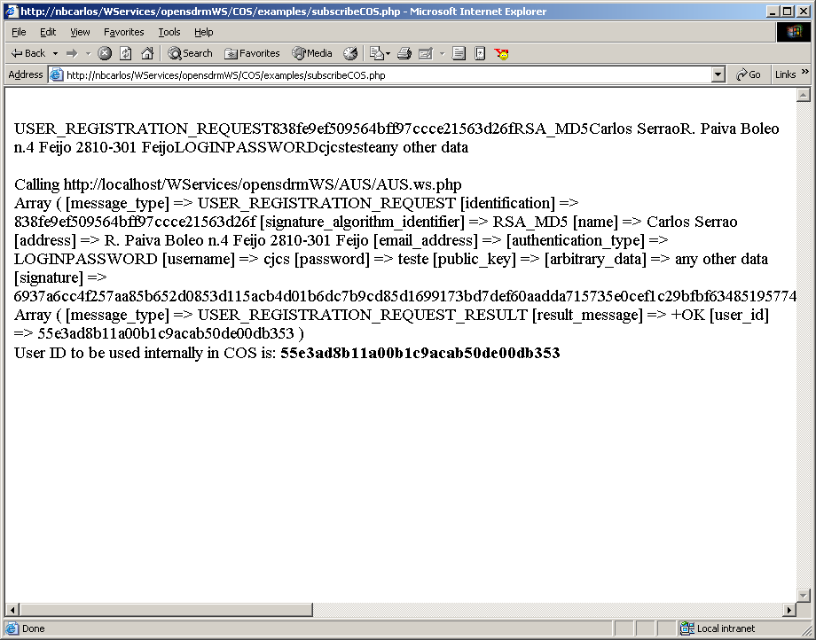

The ‘user_id’ value should then be used internally to identify the user in all COS operations.

How to verify a user authentication on the AUS
In order to verify the authentication of a user the following process may be used:

First let’s suppose that at the COS we have the following authentication screen, requesting the user its login and password.

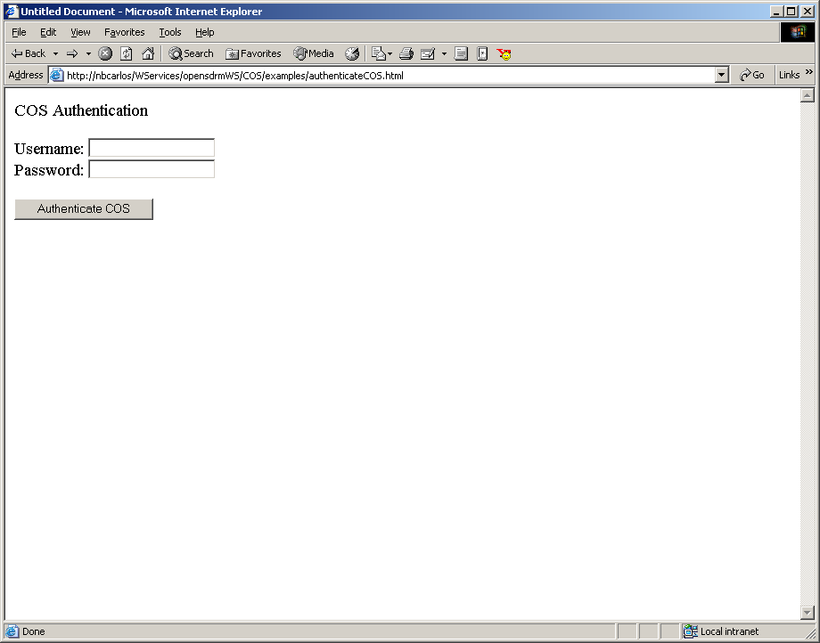

<!DOCTYPE HTML PUBLIC "-//W3C//DTD HTML 4.01 Transitional//EN">
<html>
<head>
<title>Untitled Document</title>
<meta http-equiv="Content-Type" content="text/html; charset=iso-8859-1">
</head>

<body>
<p>COS Authentication</p>
<form action="authenticateCOS.php" method="post" name="subscribeForm" id="subscribeForm">
Username:
<input name="username" type="text" id="name">
<br>
Password:
<input type="password" name="password" id="address">
<input name="authentication_type" type="hidden" id="authentication_type" value="LOGINPASSWORD">
<br>
<br>
<input type="submit" name="Submit" value="Authenticate COS">
</form>
<p>&nbsp; </p>
</body>
</html>

The following script is used to process the username and password input by the user.

<?
/*
OpenSDRM - Open Secure Digital Rights Management
Copyright (c) 2002 Adetti/MOSES

This library is free software; you can redistribute it and/or
modify it under the terms of the GNU Lesser General Public
License as published by the Free Software Foundation; either
version 2.1 of the License, or (at your option) any later version.

This library is distributed in the hope that it will be useful,
but WITHOUT ANY WARRANTY; without even the implied warranty of
MERCHANTABILITY or FITNESS FOR A PARTICULAR PURPOSE. See the GNU
Lesser General Public License for more details.

You should have received a copy of the GNU Lesser General Public
License along with this library; if not, write to the Free Software
Foundation, Inc., 59 Temple Place, Suite 330, Boston, MA 02111-1307 USA

* Created by: Carlos Serrao - ADETTI
*
* Description:
* ...
*
*/
/*
* Created by: Carlos Serrao - ADETTI
*
* Description:
* ...
*
*/

//AUS test client
include_once($_SERVER["DOCUMENT_ROOT"]."configCOS.inc.php");
require_once($_SERVER["DOCUMENT_ROOT"].$GLOBALS_CONFIG['INSTALLATION_DIR']."lib/nusoap-$NUSOAP_VERSION/nusoap.php");
include_once($_SERVER["DOCUMENT_ROOT"].$GLOBALS_CONFIG['INSTALLATION_DIR']."lib/common/RSASignature.class.php");
include_once($_SERVER["DOCUMENT_ROOT"].$GLOBALS_CONFIG['INSTALLATION_DIR']."lib/common/PublicKey.class.php");
include_once($_SERVER["DOCUMENT_ROOT"].$GLOBALS_CONFIG['INSTALLATION_DIR']."lib/common/PrivateKey.class.php");

include_once($_SERVER["DOCUMENT_ROOT"].$GLOBALS_CONFIG['INSTALLATION_DIR']."opensdrmWS/COS/admin/COS_Administrator.class.php");

$COS_Admin = new COS_Administrator();
$COS_Admin->getData();

$sig = new RSASignature();

$data_to_sign = implode("", array("AUTHENTICATION_REQUEST", $COS_Admin->cert->certificate["subjectData"]["identification"], "RSA_MD5", "LOGINPASSWORD", $username, $password));
$signature = $sig->RSA_sign($data_to_sign, $COS_Admin->privkey);

echo "<br>$data_to_sign</br>";

$parameters = array(
"message_type" => "AUTHENTICATION_REQUEST",
"identification" => $COS_Admin->cert->certificate["subjectData"]["identification"],
"signature_algorithm_identifier" => "RSA_MD5",
"authentication_type" => "LOGINPASSWORD",
"username" => $username,
"password" => $password,
"signature" => $signature
);

$web_service = $COS_PROTOCOL."://".$COS_SERVER."".$COSWS_LOCATION;

echo "<br>Calling $web_service <br>";

$soapclient = new soapclient($web_service);

print_r ($parameters);

$result = $soapclient->call('requestAuthentication', $parameters);

print_r($result);

echo "<br>User ID to be used internally in COS is: <b>".$result["user_id"]."</b><br>";

?>

The result appears in the following window.

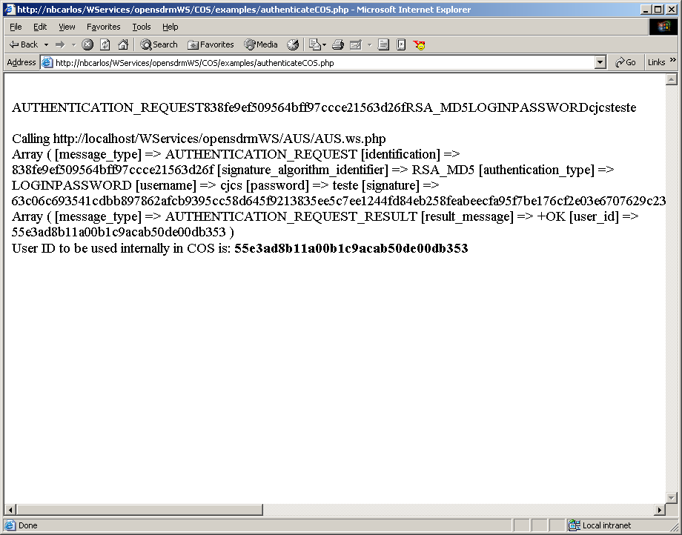

The value hole by ‘user_id’ identifies the user in the COS.

